* Experienced Teller and Accounts professional with strong leadership and relationship.
* Experienced in both Indian and UAE work environment.
* Skilled and familiar with marketing and customer handling.

**🕿**

+91- 9645713317



**Professional Experience:**

Play Guitar

🕮

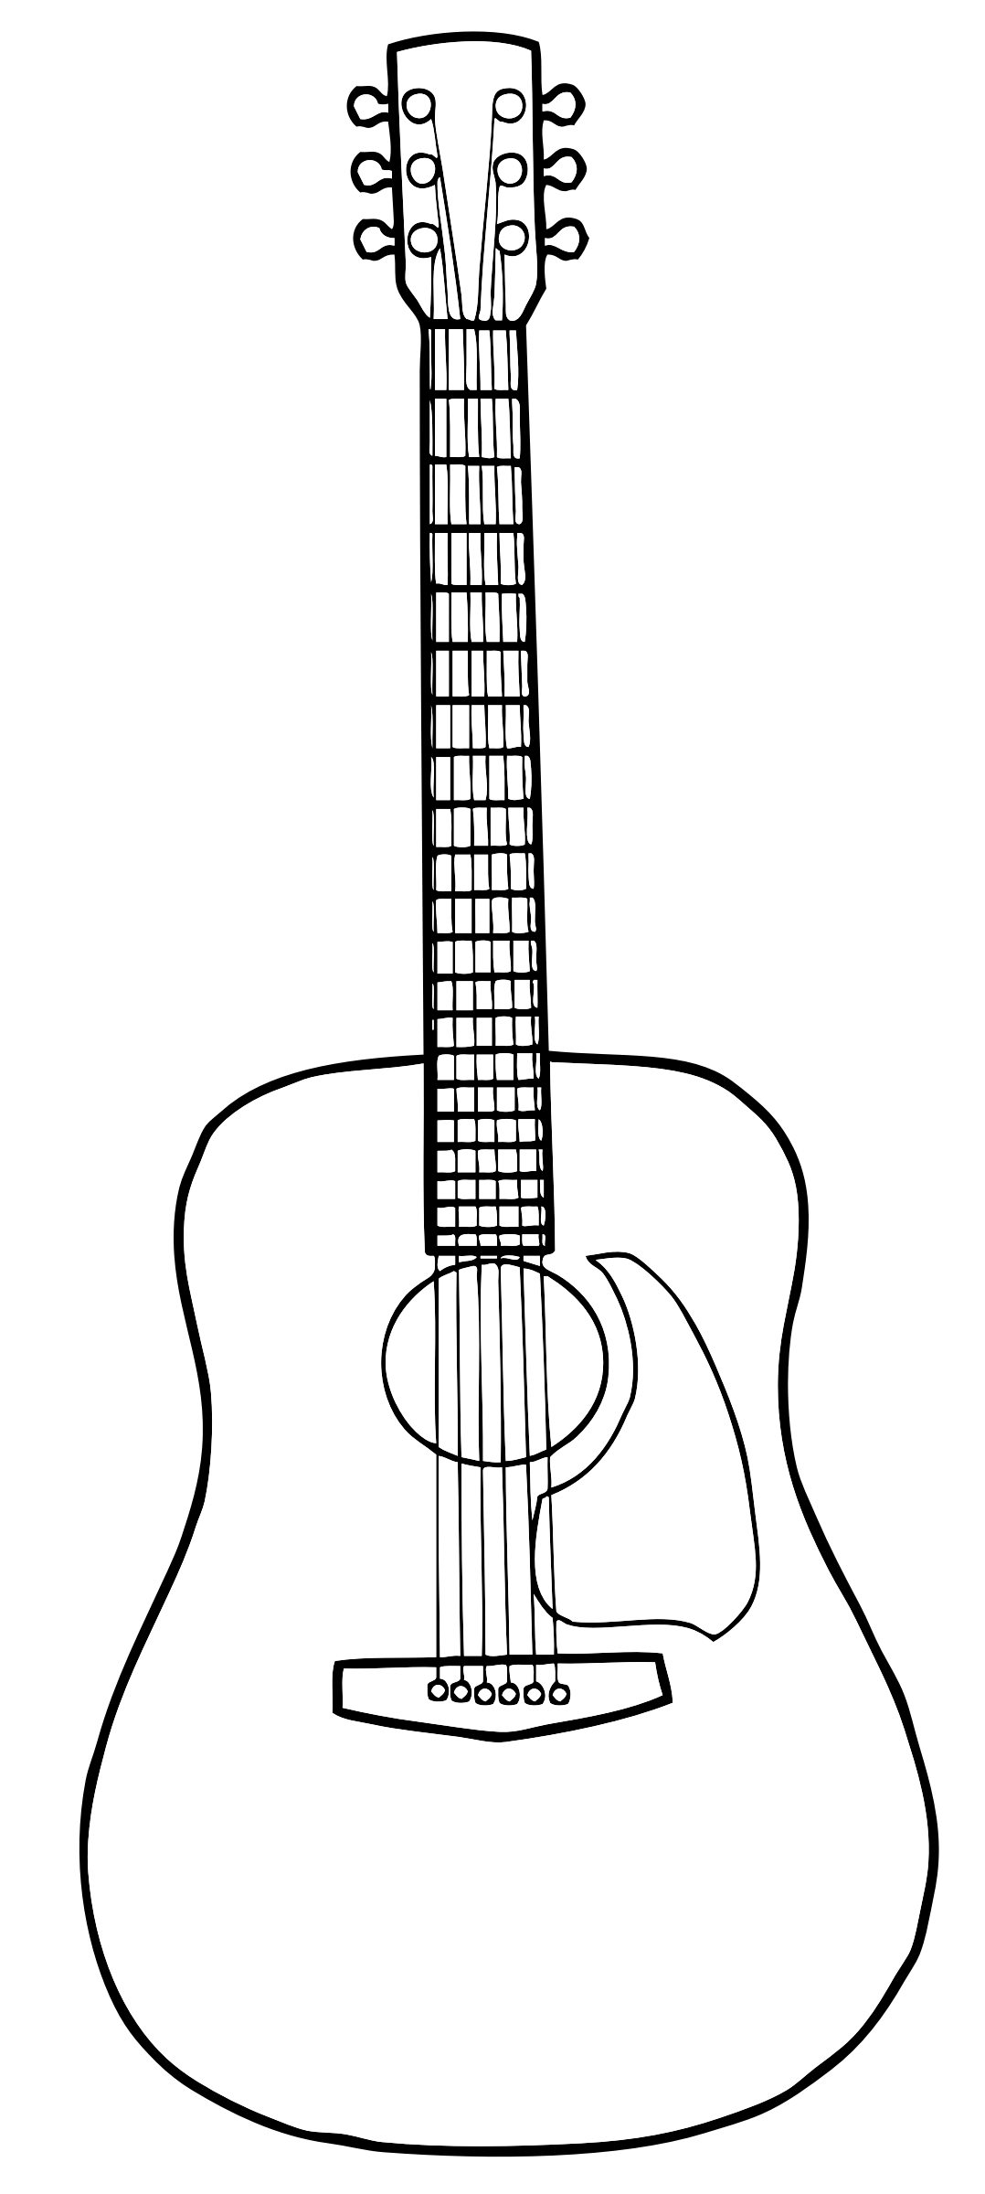

✈

Travel Around

🎜

+971-566414223

[irshadctk3317@gmail.com](mailto:irshadctk3317@gmail.com)

**🖂**

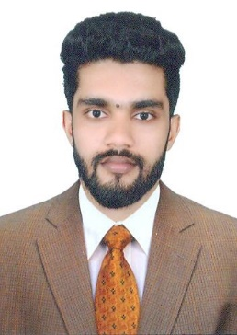

**IRSHAD CTK**

**Horalnz, Deira, Dubai UAE.**

**ACCOUNTANT**

**RAJA DHANI JEWELLERY, Kerala (India)** (Jan 2014 to July 2016)

**Sales & Accountant**

**Responsibility handled:**

* Maintained friendly and professional customer interactions at all times.
* Displaying merchandise and promoting materials.
* Preparing bills, providing warranty certificate, wrapping merchandise, making invoices, and collecting payment.
* Counting stock of the ornaments at end of duty.
* Processing tax payments and returns.
* Manage all accounting transactions.
* Handle monthly, quarterly and annual closings.
* Manage balance sheets and profit/loss statements.

**SAJWANI EXCHANGE, DUBAI (UAE)** (June 2017 to Pursuing)

**Accountant**

**Responsibility handled**:

* + Purchase and sales of foreign currency at prevailing exchange rate.
  + Pulled daily branch Balance reports.
  + Accept cash from remittance customer as per the TT voucher.
  + Maintain General ledger operations and support month end close procedures.
  + Issue cash payment and cash receipt vouchers.
  + Support month-end and year-end closing procedure.
  + Updating accounts payable.
  + Prepare MIS and cash in hand report at the end of duty.
  + Carry out smooth and error-free transaction and attend the queries, complains with high degree of accuracy.
  + Handling the branch in charge duty in absence of branch manager.

**PROFILE**

**CONTACT**

**HOBBIES**

Reading Short Novels

Listening to Musicmmmusicmusic

**Professional Experience:**

* Excellent time management skills
* Self-sufficient
* Cash handling expertise
* Positive

Power point

**Date** :

**Place:** UAE **IRSHAD CTK**

I hereby declare that all the statements and information given by me in this application are true, correct and complete to the best of my knowledge and belief.

**Declaration:**



**Father name :** Ibrahim E C

**Date of Birth :** 12/08/1994

**Age** : 25

**Marital status :** Single

**Passport No :** M4394331

**Passport Issue in :** India

**Nationality :** Indian

**Passport Info:**

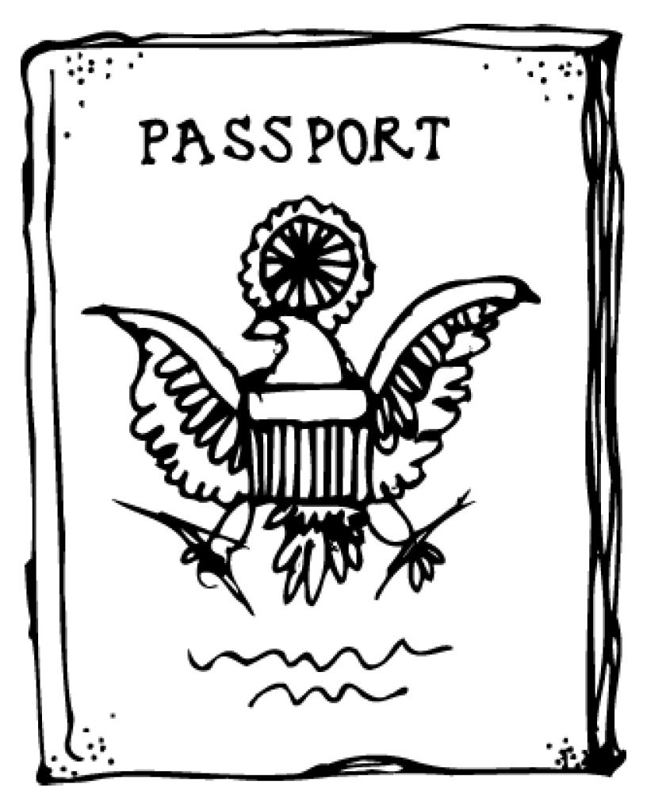

**Information:**

**Personal Details:**

**Software Skills:**

* English, Hindi, Malayalam (Read, Write & Speak)
* Arabic (Read & Write)

**Languages Known:**

**Skills:**

|  |  |  |  |  |
| --- | --- | --- | --- | --- |
| Qualification | **Institute** | **University / Board** | **Year of Passing** | percentage |
| B.com (Cooperation) | **University Of Calicut** | **University Of Calicut** | 2016 | 65% |
| VIBES | **Sree Sankaracharya** | **Kannur, Thalassery** | 2016 | --- |

MS Excel

MS Outlook

MS Word

**Education Qualification:**